# AIEO Role Description

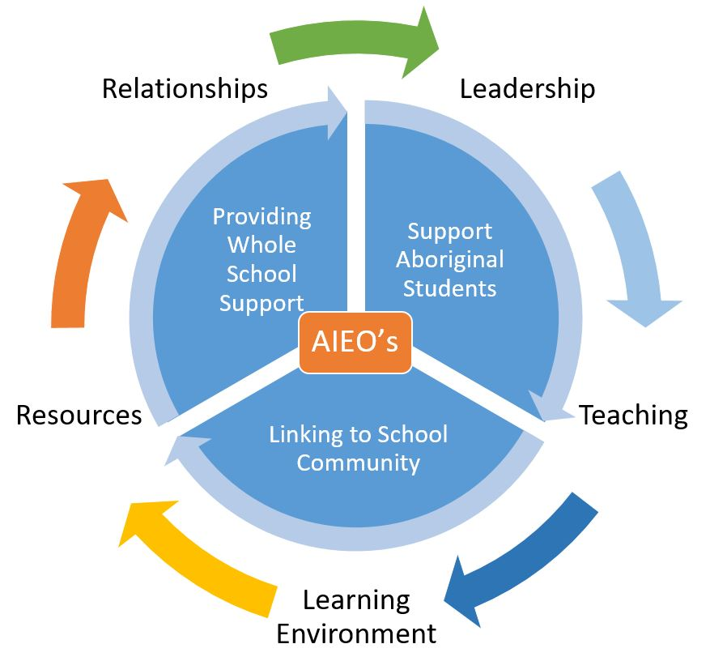

The role of the Aboriginal Islander Education Officers (AIEO) is to help promote inclusive practices within the school and build positive participation, communication and interactions between staff, Aboriginal and Torres Strait Islander students, their parents and families and the local Aboriginal community.

At Tom Price Senior High School (TPSHS) the AIEOs are employed to support Aboriginal and Torres Strait Islander students in the areas of academic achievement, social engagement, participation, attendance and behaviour.

The responsibilities of the AIEO at TPSHS are outlined and detailed under the following three areas:

1. Providing whole-school support
2. Supporting Aboriginal and Torres Strait Islander students
3. Linking school to community

# Providing Whole School Support

An important part of the AIEO role is to assist the school in taking a holistic approach to working with Aboriginal and Torres Strait Islander students and to help build mutually respectful relationships with the local community.

Cultural Awareness

Cultural awareness is a first critical step to engaging Aboriginal and Torres Strait Islander students, building strong relationships between school staff, Aboriginal and Torres Strait Islander families and their communities and development of a culturally responsive learning environment.

AIEO’s promote cultural awareness by:

* Facilitating and promoting cultural awareness training for teachers and school support staff
* Informing teachers about special cultural consideration and protocols in the local Aboriginal communities
* Informing teachers about local Aboriginal histories and cultural, language and family connections of Aboriginal and Torres Strait Island students
* Sharing knowledge about local community issues and cultural events
* Providing knowledge and understanding about the diversity of cultures and languages to promote respect and understanding
* Promoting and organising cross-cultural activities in schools (e.g. NAIDOC Week, Sorry Day, Harmony Day and Reconciliation Week)

## Whole School Planning

The AIEO’s contribute to whole-school planning involving Aboriginal and Torres Strait Islander Education by:

* Providing advice on whole-school strategies, supporting and building culturally responsive learning environments
* Participation in committees, and leadership and intervention meetings, providing an Aboriginal perspective on matters relating to Aboriginal education
* Assisting in developing learning programs, recognising the cultural and linguistic diversity and educational needs of Aboriginal and Torres Strait Islander students
* Liaising with families and the local Aboriginal and Torres Strait Islander community to develop and maintain collaborative relationships with the school
* Providing advice on accepted processes and cultural protocols for respectful interaction with the local Aboriginal community
* Providing advice on cultural values and traditions which the local Aboriginal community seeks to have reflected in the school’s learning environment and ethos.
* Contribution to the development of school and community partnership agreements.

## Influencing the Curriculum

AIEO’s contribute to building and maintaining a culturally responsive school curriculum by:

* Assisting teachers to incorporate the Aboriginal and Torres Strait Islander histories and cultures cross-curriculum priority in all learning areas through
* Providing cultural information about local areas
* Suggesting appropriate links with local Aboriginal communities and inviting local Aboriginal people into classrooms to share their cultural knowledge
* Providing Aboriginal perspectives in classroom discussions
* Sharing with teachers Aboriginal perspectives and resources across teaching and learning programs
* Encouraging and supporting the school to implements Aboriginal studies and/or language programs

# Supporting Aboriginal Students

AIEO’s and teachers play a primary role in establishing a supportive and safe learning environment in which Aboriginal and Torres Strait Islander students feel a sense of belonging and connection to the school.

## Teaching and Learning

It is imperative that AIEO’s and teachers work together to make a significant difference to the engagement, attendance, achievement and retention of Aboriginal and Torres Strait Islander students. This includes planning together, sharing ideas, discussing student matters, exchanging feedback and providing guidance.

AIEO’s supporting teaching and learning by:

* Communicating and modelling high expectations for Aboriginal and Torres Strait Islander students
* Assisting Aboriginal and Torres Strait Islander students to identify their aspirations and strive for excellence
* Assisting teachers to recognise the diverse perspectives that Aboriginal and Torres Strait Islander students bring to content being taught
* Assisting teachers in incorporate Aboriginal and Torres Strait Islander histories, cultures and languages into learning activities
* Translating and supporting students whose first language at home is not Standard Australian English
* Working with individuals and small groups of students
* Presenting lessons together, including:
* Language and communication skills
* Sport, art, music and library activities
* Delivery of Award Scheme Development and Accreditation Network (ASDAN) lessons
* Assisting in developing documented plans or personal learning plans to support Aboriginal and Torres Strait Islander students, where required
* Communicating with parents about student progress and achievement.

To build a culturally responsive curriculum and collaborate effectively with the AIEO’s it is crucial for the **teacher** to:

* Have a sound understanding of the Aboriginal Cultural Standards Framework
* Have a sound understanding of the role of the AIEO within TPSHS
* Be aware of the AIEO’s skill set and the duties they can perform
* Set aside time to collaboratively plan programs and clarify with the AIEO their role in working with students
* Advice the AIEO’s of the progress of students, behavioural issues and any relevant information.

Learning Environment

When students feel proud and strong about themselves and from here they come, and are supported to embrace their cultural identity, this can contribute to increased learning, motivation and performance.

AIEO’s play a central role in strengthening and reinforcing Aboriginal and Torres Strait Islander students’ cultural identity by:

* Providing pastoral care in areas of emotional, social and physical wellbeing, health and life skills
* Providing positive role modelling
* Mentoring and building students’ self-esteem and confidence
* Offering guidance and affirmation of cultural understandings
* Identifying opportunities and providing advice on teaching program contents related to Aboriginal and Torres Strait Islander histories, peoples, cultures and languages.

Behaviour Support

Teachers and leadership staff have the key responsibility for managing student behaviour however, AIEO’s support developments of positive student behaviour.

AIEO’s assist teachers and relevant staff to manage student behaviour by:

* Providing additional information about students’ absences and behaviour, such as events at home or other factors that may impact on the students engagement
* Contributing at behaviour management meeting, including re-entry meetings
* Assisting in developing documented plans and maintain records regarding implementing plans to support Aboriginal and Torres Strait Islander students at educational risk
* Working with individual students and groups to help them understand and achieve appropriate school behaviour
* Working together with Aboriginal and Torres Strait Islander students, their parents and families to ensure and understanding of expectations related to behaviour, engagement and learning.

AIEO’s are to be invited to attend behaviour management meetings. In the circumstance that the AIEO is not available to attend meetings they are to be informed within a reasonable time frame, of any incidents involving Aboriginal and Torres Strait Islander students.

* Involving AIEO’s at early stages can improve outcomes.

## Attendance

AIEO’s play an important role in monitoring and assisting to address Aboriginal and Torres Strait Islander students’ attendance at school by:

* Visiting families and talking to parents and community members about the importance of going to school as well as reporting on positive elements
* Supporting teachers to develop and conduct extra-curricular activities to encourage students to attend school
* Informing teachers of the reason for student absence
* Supporting students to re-engage with learning on return from a period of absence
* Working together to identify and implement strategies to engage hard-to-reach Aboriginal and Torres Strait Islander students, their parents and families
* Keeping informed about school and Department Student Attendance policies, strategies and programs.

# Linking to School Community

Culturally responsive schools build collaborative relationships between staff, Aboriginal and Torres Strait Islander students, their parents and families, and communities to support student learning. AIEO’s are an important conduit for communication and strengthening relationships between teachers, students, parents and local Aboriginal communities.

## Parents and Community

Supporting families to participate in their children’s education assists student attendance, engaging students with schooling and improving academic achievement.

AIEO’s support parents of Aboriginal and Torres Strait Islander students by:

* Being a key point of contact with the school for local community
* AIEO’s are to be notified when a new Aboriginal and/or Torres Strait Islander student is enrolling
* Making home visits
* Encouraging and organising parent involvement in school activities and learning programs
* Arranging meetings with teachers and providing support in discussions
* Sharing information and positive news stories related to individual students
* Providing information about the education system, school policies and procedures
* Assisting local Aboriginal communities to contribute cultural and linguistic knowledge and expertise to build contextual relevance to the education of Aboriginal and Torres Strait Islander students
* Contributing to making the school a welcoming, supportive and safe learning environment for Aboriginal and Torres Strait Islander students which reflects community aspirations for their children.

## Elders

Aboriginal Elders play a significant role in passing on languages, stories and cultural practices. Preserving culture is important in keeping traditions strong and ensuring the next generation has a sense of identity. It is important for Aboriginal and Torres Strait Islander students to develop strong self-esteem and feel their culture is values. This contributes to increase:

* Student engagement
* Involvement of parents in school activities
* Understanding by parent of academic and social achievement

AIEO’s support teachers and school communities to engage Aboriginal Elders by inviting them to

* Share their stories as part of planned teaching and learning programs
* Participate in school cultural activities and events
* Preform Welcome to Country and Acknowledgement of Country at school events
* Provide advice about cultural resources and material and incorporating Aboriginal histories, cultures and languages into learning activities
* Meet with the school leadership team to:
* Discuss community representation on the School Board
* Provide opportunities to develop deeper understandings about perspectives of Aboriginal people on education.

## External Agencies

Various government and non-government agencies provide assistance and support for the wellbeing of Aboriginal and Torres Strait Islander students and their families.

With the support of school and the consent of families, AIEO’s

* Provide information to parents about agencies that support families
* Compile and keep up-to-date list of local resources and contacts to give to families as required
* Support parents to meet with government and non-government agencies
* Liaise with agencies to access appropriate resources and support for parents.